ANTENATAL CARE
It is a preventive obstetric health care program aimed at optimizing maternal-fetal outcome through regular monitoring of pregnancy
OBJECTIVES OF ANTENATAL CARE
TO ENSURE:
Best possible health status for mother and fetus-
-Early detection and timely referral of high-risk pregnancy
Education of the mother about:-
♥ Physiology of pregnancy
♥ Nutrition
♥ Alarming symptoms and signs
♥ Infant care
♥ Breast feeding
♥ Child spacing
-Reduction of maternal and perinatal mortality rates
Schedule of antenatal care visit
Up to 28 weeks gestation → every 4 weeks
28-36 weeks → every 2 weeks
Thereafter → every week
In a low-risk pregnancy with no complications, minimum of five antenatal visits including the booking visits is acceptable.
First antenatal visit should be as early in pregnancy as possible
During the last visit inform the woman to return if she does not deliver within 2 weeks after the EDD
More frequent visits may be required according to the conditions (HT, anemia ,diabetes …)
Routine antenatal care visits by WHO
At least 4 visit
1st visit Before 4 months Before 16 weeks
2nd visit 6 months 24-28 weeks
3rd visit 8 months 30-32 weeks
4th visit 9 months 36-38 weeks
The initial Visit
The first antenatal visit should take place as early as possible during the first trimester.
History
Personal history
Complaints
Menstrual history
Obstetric history
present obstetric history
Family history
Medical history
Drugs or allergies
Other
Surgical history
Immunization history
Breast – feeding history
Examination
General (systemic)
Physical sign
Chest and heart examination
Breast examination
Lower limb edema
Abdominal (obstetric)
Inspection
►contour and size of abdomen
►scars of previous operations
►signs of pregnancy
►Fetal movements
►Dilated veins
►Hernia orifices
► Edema

Palpation
►fundal level (FL)
►Umbilical grip
Auscultation: fetal heart sounds (FHS)
►From 10 weeks, use the fatal heart rate director
► From 20 weeks, us the Pinard fetal stethoscope
Delivery date may be calculated by:
- Nagle's Rule based on last menstrual period (LMP)
- McDonald's Rule or Fundal height
- Ultra-sonography to measure fetal growth
- Palpate the height of fundus
Laboratory investigations
stool analysis for ova and parasites
Complete blood count (CBC)
ABO grouping and Rh type
Screening for diabetes
Venereal test
Urine analysis and culture if possible
Arrange for pelvic ultrasound if the woman is not sure of gestational age or if her period is not reliable (refer to the section on the assignment of gestational age).
Periodic Visits
At each visit the following procedures and examinations should be performed
History
●Record new complaints
● Ask about alarming signs (danger sign)
●Ask about fetal movements
●Provide continuous health education
● Encourage institutional delivery

Examination
General
● Weight
● Blood pressure (BP)
● Edema of lower limbs
Abdominal
● fundal level ( fl)
● Fetal lie
● FHS
Laboratory investigation
● HB
● Screening for diabetes at 28 weeks of pregnancy
● Urine exam for protein, glucose and ketones
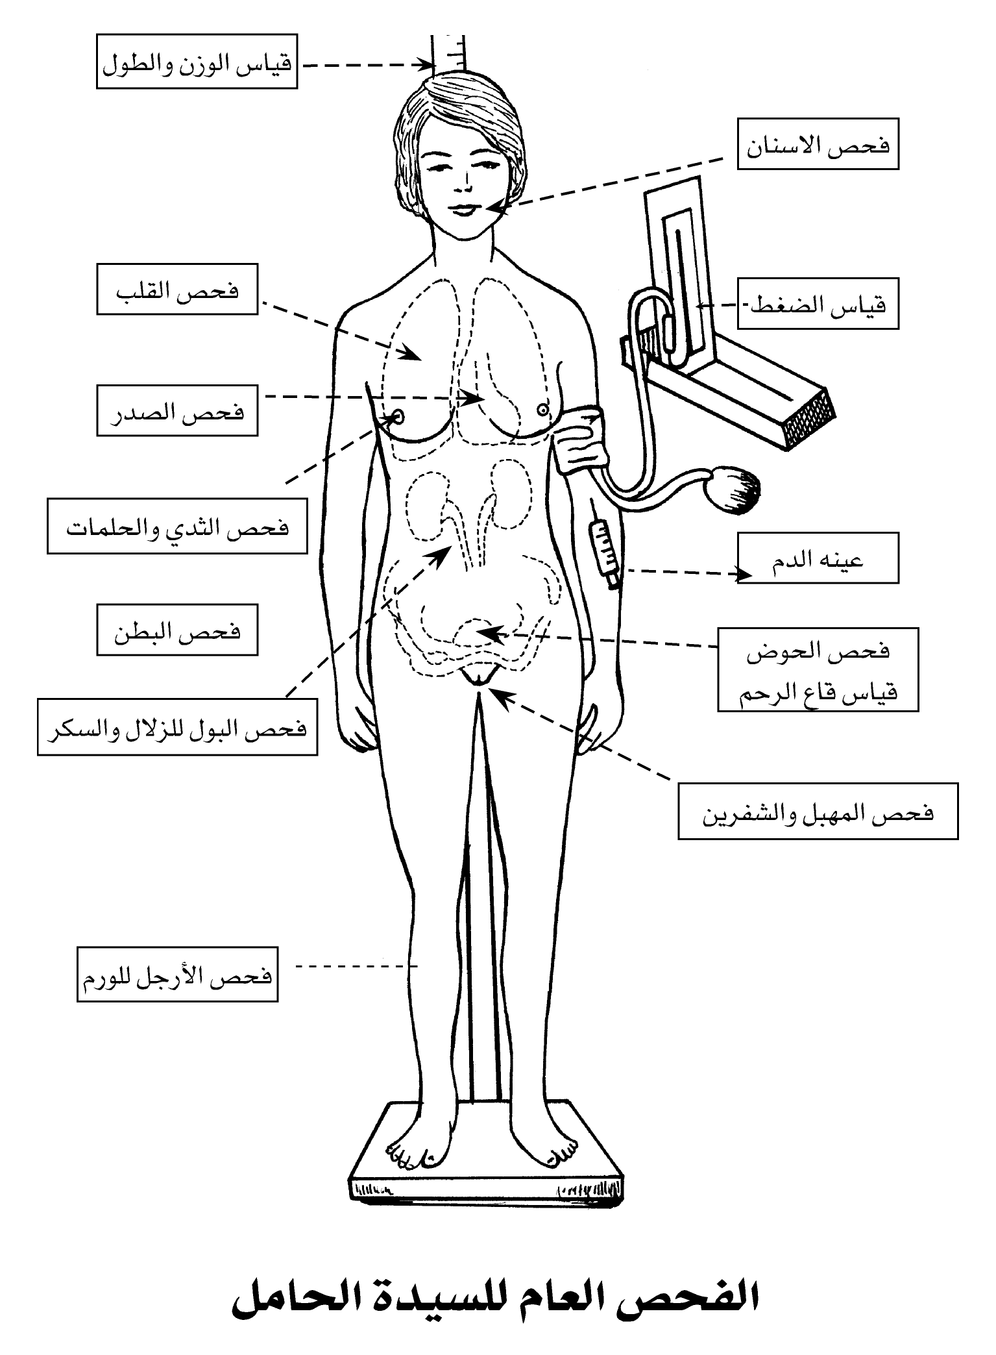
Assessment of fetal well-being in a low-risk pregnancy
● Fetal size: Assessment of the FL or the symphseal-fundal height
●Fetal kick count: at least 10 movement/12 hours
●Fetal movements: absence precedes intra uterine death (IUFD) by 48 hours
●Fetal heart sounds ( bradycardia and/or tachycardia)
● At 37 weeks Assessment of fetal size, lie and presentation
● Assessment of pelvic capacity if there is suspicion of pelvic inadequacy (stature <145 cm, pelvic fractures, or previous CS for cephalopelvic disproportion [CPD]
Counsel on nutrition
▪ Advise the woman to eat good amount and variety of healthy foods, such as meat, fish, nuts, seeds, cereals, beans, vegetables, cheese, milk, to help her feel well and strong
▪ Spend more time on nutrition counseling with very thin women and adolescents.
▪ Determine if there are important taboos about foods witch are nutritionally important for good health.
Advise the women against these taboos.
▪ talk to family members such at the partner and mother-in-law, to encourage them to help ensure the woman eats enough and avoids hard physical work.
Adequate nutrition
Calories
Excess calories lead to fat deposition and obesity
The caloric requirement is the same as in the non-pregnant state
Protein 85 gm / day
Animal sources: meat, fish, Cheese milk, and eggs
Plant sources: peas , beans,
Marked protein insufficiency in diet leads to
1-Fetal prematurely and intrauterine growth restriction(IUGR)
2-Maternal anemia and edema
Calcium 1.5 gm / day
Sources: milk, cheese , yogurt, calcium carbonate
Insufficient calcium in the diet may lead to
1-Rickets in infants
2-Osteomalacia in mothers
Iron 30mg/day
Animal sources: liver and red meat
Plant source :dark green vegetables
Insufficient iron the diet leads to maternal iron deficiency
note: if iron and calcium are prescribed, they should be taken 6-12 hours apart.
Fats
If 2/3 of proteins are taken from animal sources the intake of fats will be adequate.
Carbohydrates
Carbohydrates can be slightly reduced to compensate for the increased calorie value of the proteins and more restricted if weight reduction is necessary .
Folic acid 400 microgram / day
Megalobastic anemia form deficiency of folic may occur during pregnancy to prevent megaloblastic anemia
It is recommended that women at high risk for neural tube defects take a supplement of 4-5 mg. of folic acid/day at least 2 months before preg. And for the first 12 wk. of preg.
Health education for pregnant woman
Advise the women about:
▪ Take iron tablets
▪ Rest and avoid lifting heavy objects.
▪ Avoid smoking in pregnancy .
▪ NOT to take medication unless prescribed at the health center/hospital.
▪ Place of delivery
▪ Importance of post natal visit(1-2 weak after delivery)
▪ Importance of exclusive BF
▪ Importance of family planning

Tetanus toxoid vaccination schedule for pregnant women and women of childbearing age who have not received previous immunization against tetanus
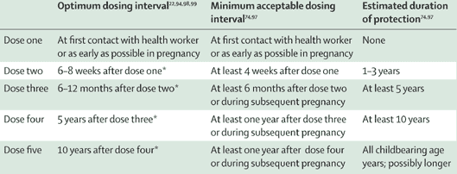

GIVE PREVENTIVE MEASURES
Give tetanus toxoid according to the immunization status
Give iron / folate
(in pregnancy ,post partum post-abortion )
Give vitamin A AFTER DELIVERY
DO NOT give capsule with high dose of vit. A during pregnancy
Advise on danger signs
Advise to go the hospital/health center immediately, day or night, WITHOUT waiting if any of the following signs :
- vaginal bleeding.
- convulsions.
- escape of fluid from the vagina
- severe headaches with blurred vision.
- fever and too weak to get out of bed.
- severe abdominal pain.
- fast or difficult breathing.
- Decrease or cessation of fetal movement
She should go to the health center as soon as possible if any of the following signs :
▪ fever .
▪ abdominal pain.
▪ feels ill.
▪ swelling of fingers, face, legs.
▪ Decrease or cessation of fetal movement
Advise to go to the facility or contact the skilled birth attendant if any of the following signs :
▪ a bloody sticky discharge.
▪ painful contractions every 20 minutes or less.
▪ waters have broken.
Advise on danger signs at home delivery
If the mother or baby has any of these sign she /they must go to the hospital/health center immediately, day or night, WITHOUT waiting

Mother
Water break and not in labor after 6 hour
Labor pains/contractions continue for more than 12 hours
Heavy bleeding after delivery (pad soaked in less than 5 minute )
Bleeding increases
Placenta not expelled 1 hour after birth of the baby
Baby
Very small
Difficult in breathing
Fits
Fever
Feels cold
Bleeding
Not able to drink
PLACE OF DELIVERY
All the fallowing condition should delivered in hospital:
- First birth
- More than 5 previous births
- Transverse lie or obvious mal presentation
- Previous CS
- Obvious multiple pregnancy
- Documented third degree tear
- History of or current vaginal bleeding or other complication during this pregnancy
- Last baby born dead or died in first day
- Prior delivery with convulsions
- Prior delivery by forceps or vacuum
Discuss how to prepare for an emergency in pregnancy
▪ Discuss emergency issues with the woman and her partner/family:
→ where will she go?
→ how will they get there?
→ how much it will cost for services and transport?
→ can she start saving straight away?
→ who will go with her for support during labour and delivery?
→ who will care for her home and other children ?

Obstetrics Overview
Obstetrics
Field of medicine that deals with pregnancy (prenatal), delivery of the baby, and the first 6 weeks after delivery (postpartum period)
Pregnancy
9 calendar months or 10 lunar months
40 weeks or 280 days
Divided into trimesters
Three intervals of 3 months each
Known as gestational period
Pregnancy
Fertilization or Conception
Union of a sperm and a mature ovum
Takes place in outer third of the fallopian tube
Zygote
Initial name for fertilized ovum
Embryo
Name of product of conception from second through 8th week of pregnancy
  - Fetus
Name of product of conception from 9th week through duration of gestational period
Two major accessory structures of pregnancy
Amniotic sac
Strong, thin-walled membranous sac that envelops and protects the growing fetus
Also known as the fetal membrane
Outer layer of sac is called the chorion
Inner layer of sac is called the amnion
Amniotic fluid within sac cushions and protects fetus during pregnancy
Placenta
Temporary organ of pregnancy
Provides for fetal respiration, nutrition, excretion
Functions as an endocrine gland by producing hormones necessary for normal pregnancy
Human chorionic gonadotropin (HCG), estrogen, progesterone, and human placental lactogen (HPL)
Maternal side of placenta
Attached to wall of uterus
Has a “beefy” red appearance
Fetal side of placenta
Has shiny, slightly grayish appearance
Contains arteries and veins that intertwine to form umbilical cord
Umbilical cord arises from center of placenta and attaches to umbilicus of fetus

