Operative Deliveries
A. Caesarian Section
An operative procedure, carried out under anesthesia whereby the fetus, placenta, and membranes are delivered through an incision in the abdominal wall and uterus.
Usually carried out after viability has been reached, 24 wks.

Definite Indications:
Cephalopelvic disproportion
Major degree of placenta previa
High order multiple pregnancy

Possible Indications:
Breech presentation
Moderate to severe pre-eclampsia
A medical condition that warrants the exclusion of maternal efforts
Diabetes Mellitus
Intrauterine growth restriction
Antepartum hemorrhage
Certain fetal abnormalities

B.Birth by Forceps
Commonly employed to expedite delivery of the fetal head or to protect the fetus, or the mother, or both from trauma and exhaustion
Classification:
1. Low cavity forceps – used when the head has reached the pelvic floor and is visible at the vulva.
2. Mid cavity forceps – used when the head is engaged and the leading part is below the level of the ischial spines.
3. High cavity forceps- considered now unsafe.

Types of Obsteric Forceps:
1. Wrigley’s forceps- designed for use when the head is on the perineum
2. Neville-Barnes or Simpson’s- used for a low cavity or mid cavity delivery when the sagittal suture is in the AP diameter of the cavity/outlet of the pelvis.
3. Keilland’s forceps – designed to deliver the fetal head or at above the pelvic brim.
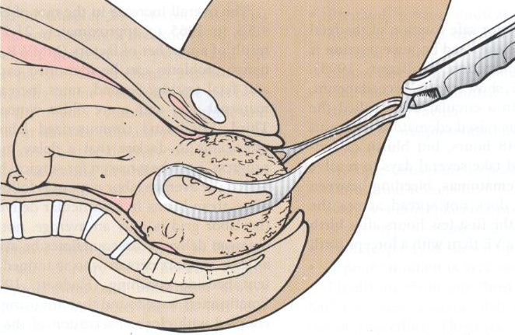
Complications of Forceps Delivery
A. Maternal
Trauma or soft tissue damage (perineum, vagina, or cervix)
Hemorrhage
Dysuria or urinary retention
Painful perineum
Postnatal morbidity
B. Neonatal
Marks on the baby’s face, which can be caused by the pressure of the forceps
Excessive bruising from the forceps
Facial Palsy —pressure from a blade compressing a facial nerve

C. Birth by Ventouse Methods
more common in Northern Europe and Africa.
An instrument that applies traction, can be used as an alternative to forceps
- Used when there is a delay in labor and when the cervix is not quite fully dilated
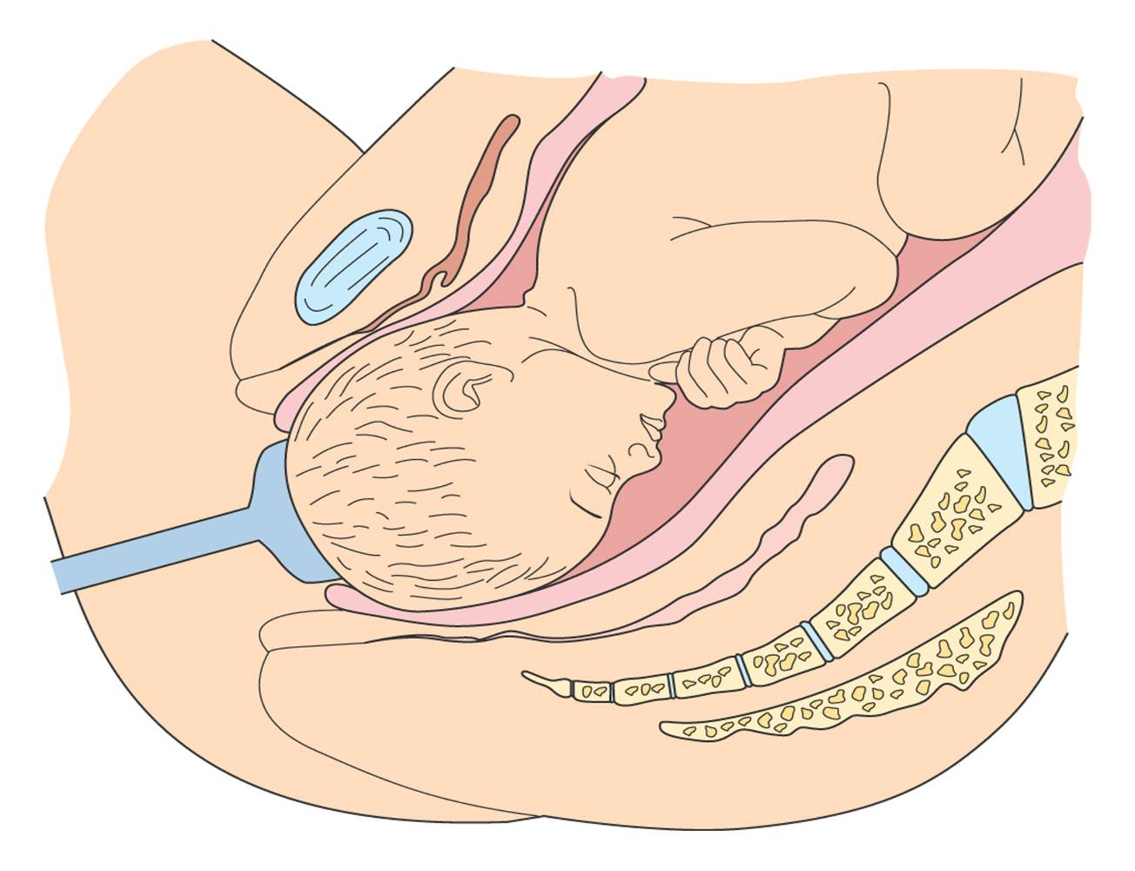
Version
The turning of the fetus from one presentation to another and may be done either externally or internally by the physician

External Cephalic Version – used to attempt to turn the fetus from a breech or shoulder presentation to a vertex presentation for birth. Done in a labor and birth setting after 37 wks.
Before it is attempted, UT scanning is done to determine fetal position, locate umbilical cord, rule out placenta previa, evaluate adequacy of maternal pelvis, assess amount of amniotic fluid,fetal age, and presence of any anomalies.

Internal version – the fetus is turned by the physician who inserts a hand into the uterus and changes the presentation to cephalic ( head) or podalic ( foot )
Internal version may be used in multi-fetal pregnancy to deliver the second fetus

Induction of Labor
Is the chemical or mechanical initiation of uterine contractions before their spontaneous onset for the purpose of bringing about the birth.
It is indicated for a variety of medical and obstetric reasons like PIH, DM, Chorioamnionitis, and other medical problems, PROM, postdate gestation, suspected fetal jeopardy, history of rapid birth, distance from the woman’s home from the hospital, and fetal death.
Here the risk to the mother or fetus is less than the risk of continuing the pregnancy.

Augmentation of labor :
Amniotomy – can be used to induce or augment labor when the condition of the cervix is favorable and the progress begins to slow.
Labor begins 12 hrs. of the rupture
Presenting part of the fetus should be engaged and well applied to the cervix to prevent cord prolapse
Oxytocin – stimulates uterine contraction. May be used to induce or augment labor that is progressing slowly because of inadequate uterine contractions

Indications for Oxytocin Induction or Augmentation of Labor :
Suspected fetal jeopardy
Inadequate uterine contractions; dystocia
PROM
Post term pregnancy
Chorioamnionitis
Maternal medical problems ( severe Rh isoimmunization, uncontrolled DM, chronic renal disease, chronic pulmonary disease)
PIH
Fetal death
Multi parous women with a history of precipitate labor

Contraindications to Oxytocin Stimulation of labor :
CPD, prolapsed cord, transverse lie
Non-reassuring FHR
Placenta previa or vasa previa
Prior classic uterine incision or surgery
Active genital herpes infection
Invasive cancer of the cervix

Episiotomy:
is a surgical incision used to enlarge the vaginal opening to help deliver a baby.
Factors that predispose:
Primigravida
Large baby, macrosomia
Posterior position of baby
Use of forceps or vacuum extractor

Preventive Measures
Perineal massage
Side-lying for expulsion
Gradual expulsion

Nursing Care
Provide comfort and patient teaching
After delivery- apply ice and assess site
