Foundations of Psychiatric-Mental health Nursing

Learning Objectives
After reading this chapter, you should be able to
- Describe characteristics of mental health and mental illness.
- Discuss the purpose and use of the American Psychiatric Association’s Diagnostic and Statistical Manual of Mental Disorders, 4th edition, Text Revision (DSM-IV-TR).
- Identify important historical landmarks in psychiatric care.
- Discuss current trends in the treatment of people with mental illness.
- Discuss the American Nurses Association standards of practice for psychiatric–mental health nursing.
- Describe common student concerns about psychiatric nursing.

AS YOU BEGIN THE STUDY OF psychiatric–mental health nursing, you may be excited, uncertain, and even a little anxious. The field of mental health often seems a little unfamiliar or mysterious, making it hard to imagine what the experience will be like or what nurses do in this area. This chapter addresses these concerns and others by providing an overview of the history of mental illness, advances in treatment, current issues in mental health, and the role of the psychiatric nurse.
MENTAL HEALTH AND MENTAL ILLNESS
- Mental health and mental illness are difficult to define precisely.
- People who can carry out their roles in society and whose behavior is appropriate and adaptive are viewed as healthy.
- Conversely, those who fail to fulfill roles and carry out responsibilities or whose behavior is inappropriate are viewed as ill.
- The culture of any society strongly influences its values and beliefs, and this in turn affects how that society defines health and illness. What one society may view as acceptable and appropriate, another society may see as maladaptive and inappropriate.

Mental Health
The World Health Organization defines health as a state of complete physical, mental, and social wellness, not merely the absence of disease or infirmity.
This definition emphasizes health as a positive state of wellbeing.
People in a state of emotional, physical, and social well-being:
- Achieves life responsibilities
- functions effectively in daily life
- Satisfied with their interpersonal relationships and themselves.
No single universal definition of mental health exists. Generally, a person’s behavior can provide clues to his or her mental health. Because each person can have a different view or interpretation of behavior (depending on his or her values and beliefs), the determination of mental health may be difficult.
In most cases, mental health is a state of:
- Emotional, psychological and social wellness
Evidenced by:
- Satisfying interpersonal relationships
- Effective behavior and coping
- Positive self-concept
- Emotional stability.
Mental health has many components, and a wide variety of factors influence it. These factors interact; thus, a person’s mental health is a dynamic, or ever-changing, state.
Factors influencing a person’s mental health can be categorized as:
- Individual, interpersonal and social/cultural.
- Individual, or personal, factors include:
- Vitality
- Self-esteem
- Reality orientation
- Sense of belonging
- Capacity for growth
- A person’s biologic makeup
- Autonomy and independence
- Ability to find meaning in life
- Emotional resilience or hardiness
- Coping or stress management abilities.
- Interpersonal, or relationship, factors include:
- Effective communication
- Ability to help others
- Intimacy
- Balance of separateness and connectedness.
- Social/cultural, or environmental, factors include:
- A sense of community
- Access to adequate resources
- Intolerance of violence
- Support of diversity among people
- Mastery of the environment
- Positive
- Realistic view of one’s world.

Mental Illness
The American Psychiatric Association (APA, 2000) defines a mental disorder as:
- “a clinically significant behavioral or psychological syndrome or pattern that occurs in an individual and is associated with present distress (e.g., a painful symptom) or disability (i.e., impairment in one or more important areas of functioning) or with a significantly increased risk of suffering death, pain, disability, or an important loss of freedom” (p. xxxi).
General criteria to diagnose mental disorders include:
- Dissatisfaction with one’s characteristics, abilities, and accomplishments
- Ineffective or unsatisfying relationships
- Dissatisfaction with one’s place in the world
- Ineffective coping with life events
- Lack of personal growth.
In addition, the person’s behavior must not be culturally expected or approved. However, deviant behavior does not necessarily indicate a mental disorder (APA, 2000).
Factors contributing to mental illness can also be viewed within individual, interpersonal, and social/cultural categories.

Individual factors include:
- Biologic makeup
- Intolerable or unrealistic worries or fears
- Inability to distinguish reality from fantasy
- Intolerance of life’s uncertainties
- Sense of disharmony in life
- Loss of meaning in one’s life
Interpersonal factors include:
- Ineffective communication
- Excessive dependency on or withdrawal from relationships
- Loss Sense of belonging
- Inadequate social support
- Loss of emotional control.
Social/cultural factors include:
- Lack of resources
- Violence
- Homelessness
- Poverty
- Unwarranted negative view of the world
- Discrimination such as stigma, racism, (classism; Prejudice based on social class), (ageism; Discrimination against middle-aged and elderly people), and sexism)

HISTORICAL PERSPECTIVES OF THE TREATMENT OF MENTAL ILLNESS
Ancient Times
- People of ancient times believed that any sickness indicated displeasure of the gods and, in fact, was a punishment for sins and wrongdoing.
- Those with mental disorders were viewed as being either divine or demonic, depending on their behavior. Individuals seen as divine were worshipped and adored; those seen as demonic were ostracized, punished, and sometimes burned at the stake.
- Later, Aristotle (382–322 BC) attempted to relate mental disorders to physical disorders and developed his theory that the amounts of blood, water, and yellow and black bile in the body controlled the emotions. These four substances, or humors, corresponded with happiness, calmness, anger, and sadness. Imbalances of the four humors were believed to cause mental disorders, so treatment was aimed at restoring balance through bloodletting, starving, and purging. Such “treatments” persisted well into the 19th century (Baly, 1982).
- In early Christian times (1–1000 AD), primitive beliefs and superstitions were strong. All diseases were again blamed on demons, and the mentally ill were viewed as possessed.
- Priests performed exorcisms to rid evil spirits. When that failed, they used more severe and brutal measures, such as incarceration in dungeons, flogging, and starving.
- In England during the Renaissance (1300–1600), people with mental illness were distinguished from criminals.
- Those considered harmless were allowed to wander the countryside or live in rural communities, but the more “dangerous lunatics” were thrown in prison, chained, and starved (Rosenblatt, 1984).
- In 1547, the Hospital of St. Mary of Bethlehem was officially declared a hospital for the insane, the first of its kind.
- By 1775, visitors at the institution were charged a fee for the privilege of viewing and ridiculing the inmates, who were seen as animals, less than human (McMillan, 1997).
- During this same period in the colonies (later the United States), the mentally ill were considered evil or possessed and were punished. Witch hunts were conducted, and offenders were burned at the stake.
Period of Enlightenment and Creation of Mental Institutions
- In the 1790s, a period of enlightenment concerning persons with mental illness began.
- Phillippe Pinel in France and William Tukes in England formulated the concept of asylum as a safe refuge or haven offering protection at institutions where people were whipped, beaten, and starved just because they were mentally ill (Gollaher, 1995).
- With this movement began the moral treatment of the mentally ill. In the United States, Dorothea Dix (1802–1887) began a crusade to reform the treatment of mental illness after a visit to Tukes’s institution in England.
- She was instrumental in opening 32 state hospitals that offered asylum to the suffering.
- Dix believed that society was obligated to those who were mentally ill; she advocated adequate shelter, nutritious food, and warm clothing (Gollaher, 1995).
- The period of enlightenment was short-lived. Within100 years after establishment of the first asylum, state hospitals were in trouble. Attendants were accused of abusing the residents, the rural locations of hospitals were viewed as isolating patients from their families and homes, and the phrase insane asylum took on a negative connotation.
Sigmund Freud and Treatment of Mental Disorders
- The period of scientific study and treatment of mental disorders began with Sigmund Freud (1856–1939) and others, such as Emil Kraepelin (1856–1926) and Eugene Bleuler(1857–1939).
- With these men, the study of psychiatry and the diagnosis and treatment of mental illness started in earnest.
- Freud challenged society to view human beings objectively.
- He studied the mind, its disorders, and their treatment as no one had done before.
- Many other theorists built on Freud’s pioneering work (see Chapter 3). Kraepelin began classifying mental disorders according to their symptoms, and Bleuler coined the term schizophrenia.
Development of Psychopharmacology
A great leap in the treatment of mental illness began in about 1950 with the development of psychotropic drugs, or drugs used to treat mental illness.
- Chlorpromazine (Thorazine), an antipsychotic drug
- lithium, an antimanic agent, were the first drugs to be developed
Over the following 10 years:
- Monoamine oxidase inhibitor antidepressants
- Haloperidol (Haldol), an antipsychotic
- Tricyclic antidepressants
- Antianxiety agents, called benzodiazepines, were introduced.
For the first time, drugs actually reduced agitation, psychotic thinking, and depression. Hospital stays were shortened, and many people were well enough to go home. The level of noise, chaos, and violence greatly diminished in the hospital setting.

Move toward Community Mental Health
- The movement toward treating those with mental illness in less restrictive environments gained momentum in 1963 with the enactment of the Community Mental Health Centers Construction Act.
- Deinstitutionalization, a deliberate shift from institutional care in state hospitals to community facilities, began.
- Community mental health centers served smaller geographic catchment, or service, areas that provided less restrictive treatment located closer to individuals’ homes, families, and friends.
These centers provided:
- Emergency care
- Inpatient care
- Outpatient services
- Partial hospitalization
- Screening services
- Education.
- Thus, deinstitutionalization accomplished the release of individuals from long-term stays in state institutions, the decrease in admissions to hospitals, and the development of community based services as an alternative to hospital care.
- Deinstitutionalization, federal legislation was passed to provide an income for disabled persons: Supplemental Security Income (SSI) and Social Security Disability Income (SSDI).
- This allowed people with severe and persistent mental illness to be more independent financially and to not rely on family for money. States were able to spend less money on care of the mentally ill than they had spent when these individuals were in state hospitals because this program was federally funded.

MENTAL ILLNESS IN THE 21ST CENTURY
- The National Institute of Mental Health (NIMH, 2008) estimates that more than 26% of Americans aged 18 years and older have a diagnosable mental disorder— approximately 57.7 million persons each year.
- Furthermore, mental illness or serious emotional disturbances impair daily activities for an estimated 15 million adults and 4 million children and adolescents. For example, attention deficit hyperactivity disorder affects 3% to 5% of school-aged children. More than 10 million children younger than 7 years grow up in homes where at least one parent suffers from significant mental illness or substance abuse, a situation that hinders the readiness of these children to start school.
- The economic burden of mental illness in the United States, including both healthcare costs and lost productivity, exceeds the economic burden caused by all kinds of cancer.
- Mental disorders are the leading cause of disability in the United States and Canada for persons 15 to 44 years of age. Yet only one in four adults and one in five children and adolescents requiring mental health services get the care they need.
- Some believe that deinstitutionalization has had negative as well as positive effects.
- Although deinstitutionalization reduced the number of public hospital beds by 80%, the number of admissions to those beds correspondingly increased by 90%. Such findings have led to the term revolving door effect.
- Although people with severe and persistent mental illness have shorter hospital stays, they are admitted to hospitals more frequently.
- The continuous flow of clients being admitted and discharged quickly overwhelms general hospital psychiatric units.
- In some cities, emergency department visits for acutely disturbed persons have increased by 400 to 500%.

Objectives for the Future
Unfortunately, only one in four affected adults and one in five children and adolescents receive treatment (Department of Health and Human Services [DHHS], 2008). Statistics like these underlie the Healthy People 2010 objectives for mental health proposed by the U.S. DHHS (2000; Box 1.1). These objectives, originally developed as Healthy People 2000, were revised in January 2000 to increase the number of people who are identified, diagnosed, treated, and helped to live healthier lives. The objectives also strive to decrease rates of suicide and homelessness, to increase employment among those with serious mental illness, and to provide more services both for juveniles and for adults who are incarcerated and have mental health problems. At this time, work has begun on Healthy People2020 goals, which will be released in January 2010.
Community-Based Care
After deinstitutionalization, the 2,000 community mental health centers that were supposed to be built by 1980 had not materialized. By 1990, only 1,300 programs provided various types of psychosocial rehabilitation services. Persons with severe and persistent mental illness were either ignored or underserved by community mental health centers. This meant that many people needing services were, and still are, in the general population with their needs unmet. The Treatment Advocacy Center (2008) reports that about one half of all persons with severe mental illness have received no treatment of any kind in the previous 12 months. Persons with minor or mild cases are more likely to receive treatment, whereas those with severe and persistent mental illness are least likely to be treated.
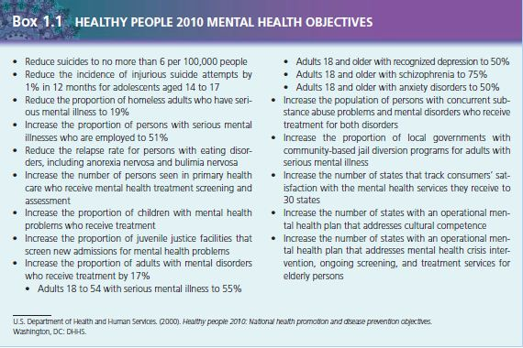

Cost containment and managed care
- Health-care costs spiraled upward throughout the 1970s and 1980s in the United States.
- Managed care is a concept designed to purposely control the balance between the quality of care provided and the cost of that care.
- In a managed care system, people receive care based on need rather than on request.
- Those who work for the organization providing the care assess the need for care. Managed care began in the early 1970s in the form of health maintenance organizations, which were successful in some areas with healthier populations of people.
Cultural considerations
The u.s. Census bureau (2000) estimates that 62% of the population has European origins. This number is expected to continue to decrease as more u.s. Residents trace their ancestry to african, asian, arab, or hispanic origins. Nurses must be prepared to care for this culturally diverse population, which includes being aware of cultural differences that influence mental health and the treatment of mental illness. See chapter 7 for a discussion of cultural differences. Diversity is not limited to culture; the structure of families has changed as well. With a divorce rate of 50% in the united states, single parents head many families and many blended families are created when divorced persons remarry. Twenty-five percent of households consist of a single person (u.s. Census bureau, 2000), and many people live together without being married. Gay men and lesbians form partnerships and sometimes adopt children. The face of the family in the united states is varied, providing a challenge to nurses to provide sensitive, competent care.

PSYCHIATRIC NURSING PRACTICE:
- In 1873, Linda Richards graduated from the New England Hospital for Women and Children in Boston. She went on to improve nursing care in psychiatric hospitals and organized educational programs in state mental hospitals in Illinois.
- Richards is called the first American psychiatric nurse; she believed that “the mentally sick should be at least as well cared for as the physically sick” (Doona, 1984).
- The first training of nurses to work with persons with mental illness was in 1882 at McLean Hospital in Belmont, Massachusetts. The care was primarily custodial and focused on nutrition, hygiene, and activity.
- Nurses adapted medical– surgical principles to the care of clients with psychiatric disorders and treated them with tolerance and kindness.
- The role of psychiatric nurses expanded as somatic therapies for the treatment of mental disorders were developed.
- Treatments, such as insulin shock therapy (1935), psychosurgery (1936), and electroconvulsive therapy (1937), required nurses to use their medical–surgical skills more extensively.
- The first psychiatric nursing textbook, Nursing Mental Diseases by Harriet Bailey, was published in 1920. In 1913, Johns Hopkins was the first school of nursing to include a course in psychiatric nursing in its curriculum.
- It was not until 1950 that the National League for Nursing, which accredits nursing programs, required schools to include an experience in psychiatric nursing.
- Two early nursing theorists shaped psychiatric nursing practice: Hildegard Peplau and June Mellow. Peplau published Interpersonal Relations in Nursing in 1952 and Interpersonal Techniques: The Crux of Psychiatric Nursing in 1962. She described the therapeutic nurse–client relationship with its phases and tasks and wrote extensively about anxiety (see Chapter 13).
- The interpersonal dimension that was crucial to her beliefs forms the foundations of practice today. Mellow’s 1968 work, Nursing Therapy, described her approach of focusing on clients’ psychosocial needs and strengths. Mellow contended that the nurse as therapist is particularly suited to working with those with severe mental illness in the context of daily activities, focusing on the here and now to meet each person’s psychosocial needs (1986). Both Peplau and Mellow substantially contributed to the practice of psychiatric nursing. In 1973, the division of psychiatric and mental health practice of the American Nurses Association (ANA) developed standards of care, which it revised in 1982, 1994, 2000, and 2007. Standards of care are authoritative statements by professional organizations that describe the responsibilities for

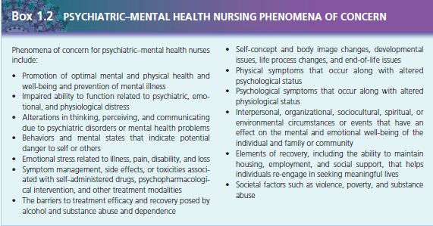
Which nurses are accountable? They are not legally binding unless they are incorporated into the state nurse practice act or state board rules and regulations.
When legal problems or lawsuits arise, these professional standards are used to determine safe and acceptable practice and to assess the quality of care. This document also outlines the areas of practice and phenomena of concern for today’s psychiatric–mental health nurse. The phenomena of concern describe the 13 areas of concern that mental health nurses focus on when caring for clients (Box 1.2). The standards of care incorporate the phases of the nursing process, including specific types of interventions, for nurses in psychiatric settings and outline standards for professional performance: quality of care, performance appraisal, education, collegiality, ethics, collaboration, research, and resource utilization (Box 1.3). Box 1.4 summarizes specific areas of practice and specific interventions for both basic and advanced nursing practice.
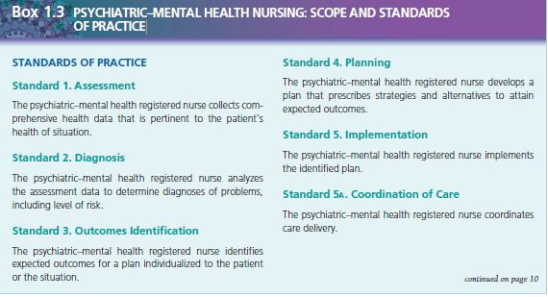
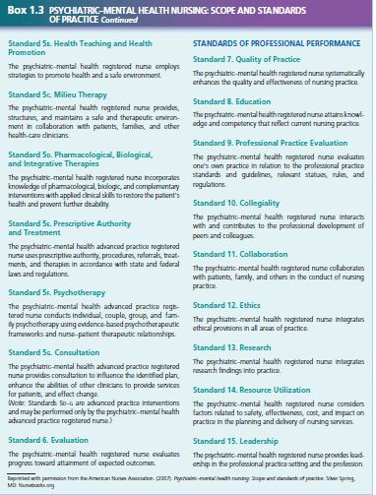

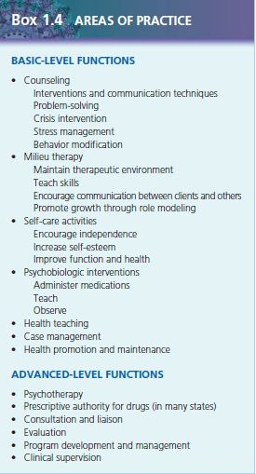

Student Concerns
Student nurses beginning their clinical experience in psychiatric–mental health nursing usually find the discipline to be very different from any previous experience. As a result, they often have a variety of concerns; these concerns are normal and usually do not persist once the students have initial contacts with clients. Some common concerns and helpful hints for beginning students follow:
• What if I say the wrong thing?
No one magic phrase can solve a client’s problems; likewise, no single statement can significantly worsen them. Listening carefully, showing genuine interest, and caring about the client are extremely important. A nurse who possesses these elements but says something that sounds out of place can simply restate it by saying, “That didn’t come out right. What I meant was . . .”
• What will I be doing?
In the mental health setting, many familiar tasks and responsibilities are minimal. Physical care skills or diagnostic tests and procedures are fewer than those conducted in a busy medical–surgical setting. The idea of “just talking to people” may make the student feel as though he or she is not really doing anything. The student must deal with his or her own anxiety about approaching a stranger to talk about very sensitive and personal issues. Development of the therapeutic nurse–client relationship and trust takes time and patience.
• What if no one will talk to me?
Students sometimes fear that clients will reject them or refuse to have anything to do with student nurses. Some clients may not want to talk or are reclusive, but they may show that same behavior with experienced staff; students should not see such behavior as a personal insult or failure. Generally, many people in emotional distress welcome the opportunity to have someone listen to them and show a genuine interest in their situation. Being available and willing to listen is often all it takes to begin a significant interaction with someone.
• Am I prying when I ask personal questions?
Students often feel awkward as they imagine themselves discussing personal or distressing issues with a client. It is important to remember that questions involving personal matters should not be the first thing a student says to the client. These issues usually arise after some trust and rapport have been established. In addition, clients genuinely are distressed about their situations and often want help resolving issues by talking to the nurse. When these emotional or personal issues are addressed in the context of the nurse–client relationship, asking sincere and necessary questions is not prying but is using therapeutic communication skills to help the client.
• How will I handle bizarre or inappropriate behavior?
The behavior and statements of some clients may be shocking or distressing to the student initially. It is important to monitor one’s facial expressions and emotional responses so that clients do not feel rejected or ridiculed The nursing instructor and staff are always available to assist the student in such situations. Students should never feel as if they will have to handle situations alone.
• What happens if a client asks me for a date or displays sexually aggressive or inappropriate behavior?
Some clients have difficulty recognizing or maintaining interpersonal boundaries. When a client seeks contact of any type outside the nurse–client relationship, it is important for the student (with the assistance of the instructor or staff) to clarify the boundaries of the professional relationship (see Chapter 5). Likewise, setting limits and maintaining boundaries are needed when a client’s behavior is sexually inappropriate. Initially, the student might be uncomfortable dealing with such behavior, but with practice and the assistance of the instructor and staff, it becomes easier to manage. It is also important to protect the client’s privacy and dignity when he or she cannot do so.
• Is my physical safety in danger?
Often students have had little or no contact with seriously mentally ill people. Media coverage of those with mental illness who commit crimes is widespread, leaving the impression that most clients with psychiatric disorders are violent. Actually, clients hurt themselves more often than they harm others. Staff members usually closely monitor clients with a potential for violence for clues of an impending outburst. When physical aggression does occur, staff members are specially trained to handle aggressive clients in a safe manner. The student should not become involved in the physical restraint of an aggressive client because he or she has not had the training and experience required. When talking to or approaching clients who are potentially aggressive, the student should sit in an open area rather than in a closed room, provide plenty of space for the client, or request that the instructor or a staff person be present.
• What if I encounter someone I know being treated on the unit?
In any clinical setting, it is possible that a student nurse might see someone he or she knows. People often have additional fears because of the stigma that is still associated with seeking mental health treatment. It is essential in mental health that the client’s identity and treatment be kept confidential. If the student recognizes someone he or she knows, the student should notify the instructor, who can decide how to handle the situation. It is usually best for the student (and sometimes the instructor or staff) to talk with the client and reassure him or her about confidentiality. The client should be reassured that the student will not read the client’s record and will not be assigned to work with the client.
• What if I recognize that I share similar problems or backgrounds with clients?
Students may discover that some of the problems, family dynamics, or life events of clients are similar to their own or those of their family. It can be a shock for students to discover that sometimes there are as many similarities between clients and staff as there are differences. There is no easy answer for this concern. Many people have stressful lives or abusive childhood experiences; some cope fairly successfully, whereas others are devastated emotionally. Although we know that coping skills are a key part of mental health, we do not always know why some people have serious emotional problems and others do not. Chapter 7 discusses these factors in more detail.
SELF-AWARENESS ISSUES
Self-awareness is the process by which the nurse gains recognition of his or her own feelings, beliefs, and attitudes. In nursing, being aware of one’s feelings, thoughts, and values is a primary focus. Self-awareness is particularly important in mental health nursing. Everyone, including nurses and student nurses, has values, ideas, and beliefs that are unique and different from others’. At times, a nurse’s values and beliefs will conflict with those of the client or with the client’s behavior. The nurse must learn to accept these differences among people and view each client as a worthwhile person regardless of that client’s opinions and lifestyle. The nurse does not need to condone the client’s views and behavior; he or she merely needs to accept them as different from his or her own and not let them interfere with care. For example, a nurse who believes that abortion is wrong may be assigned to care for a client who has had an abortion. If the nurse is going to help the client, he or she is able to separate his or her own beliefs about abortion from those of the client: the nurse must make sure personal feelings and beliefs do not interfere with or hinder the client’s care. The nurse can accomplish self-awareness through reflection, spending time consciously focusing on how one feels and what one values or believes. Although we all have values and beliefs, we may not have really spent time discovering how we feel or what we believe about certain issues, such as suicide or a client’s refusal to take needed medications. The nurse needs to discover himself or herself and what he or she believes before trying to help others with different views.
Points to Consider When Working on Self-Awareness
• Keep a diary or journal that focuses on experiences and related feelings. Work on identifying feelings and the circumstances from which they arose. Review the diary or journal periodically to look for patterns or changes.
• Talk with someone you trust about your experiences and feelings. This might be a family member, friend, coworker, or nursing instructor. Discuss how he or she might feel in a similar situation, or ask how he or she deals with uncomfortable situations or feelings.
• Engage in formal clinical supervision. Even experienced clinicians have a supervisor with whom they discuss personal feelings and challenging client situations to gain insight and new approaches.
• Seek alternative points of view. Put yourself in the client’s situation and think about his or her feelings, thoughts, and actions.
• Do not be critical of yourself (or others) for having certain values or beliefs. Accept them as a part of yourself, or work to change those values and beliefs you wish to be different.
Critical Thinking Questions
- In your own words, describe mental health. Describe the characteristics, behavior, and abilities of someone who is mentally healthy.
- When you think of mental illness, what images or ideas come to mind? Where do these ideas come from—movies, television, personal experience?
- What personal characteristics do you have that indicate good mental health?

