Lab 6
Electrocardiograph (ECG)
IS a recording of electrical potentials generated by the current due to heart impulses, this current can be measured by electrodes are placed on the skin on opposite side of the heart called leads. There are 12 leads are Lead I, lead II, lead III, aVR, aVL , aVF, V1,V2,V3,V4,V5,V6. Electrodes are placed according to Einthoven Triangle. LeadI on both arms, LeadII on RA AND LL, LeadIII LA AND LL.
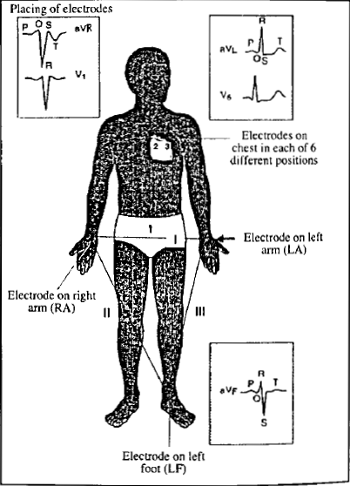

Elecrtopotentials of the heart are measured by electrocardiograph. Electrical potentials are formed due to differences in heart impulses polarity (one heart side is positive while the other is negative in the meantime).

How to read ECG paper
There are three main waves
- P wave represent atria depolarization (Contraction), normal P wave is about 0.12 sec
- QRS wave is Ventricles depolarization, normal wave is 0.10 sec
- T wave is repolarization of heart ventricles is about 3 squares
Prolonged P-R is an indicator of damaged heart tissues, Prolonged QRS represents ventricular hypertrophy.

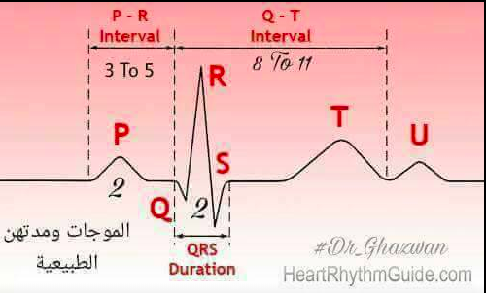
P-R is measured as the distance from P TO QRS complex, It’s about 0.12-0.20 SEC.
S-T is measured from the end of S to the start of T wave, it’s about 5 mml in height, if it exceeds 10 mml, this refer to myocardial infraction.
U sometimes appear and always in upside direction, if it inverted, represent myocardial infraction.
ECG can identify the following diseases
- Myocardial ischemia and infraction
- Pericarditis
- Chamber hypertrophy
- Electrolytes disturbance
- Drug toxicity (prolong QT interval)

Pacemakers of the heart
SA node: dominant pacemaker with intrinsic rate of 60-100 beats/min
AV node: back up pacemaker with intrinsic rate of 40-60 beats/min
Ventricular cells: back up pacemaker with intrinsic rate of 20-45 beats/min

